1. **Write a program to implement symmetric encryption using Ceaser Cipher algorithm.**

**Code:-**

def encrypt(text,s):

    result=""

    for i in range(len(text)):

        char=text[i]

        #Encrypt uppercase characters in plain text

        if(char==" "):

            result+=" "

        else:

            if(char.isupper()):

                #chr() funtion return character that represents specified unicode

                #ord() function return the number

                result+=chr((ord(char) + s - 65) % 26 + 65)

            else:

                result+=chr((ord(char) + s - 97) % 26 + 97)

    return result

text="Hello 1"

s=4

print("plain text:"+text)

print("Shift pattern : "+str(s))

print("cipher "+encrypt(text,s))

**Output:-**

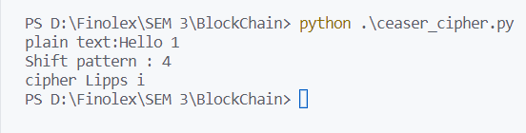

1. **Write a program to implement asymmetric encryption using RSA algorithm. Generate both the keys public key and private key and store it in file. Also encrypt and decrypt the message using keys.**

**Code:-**

from Crypto.Cipher import PKCS1_OAEP

from Crypto.PublicKey import RSA

from binascii import hexlify

message=b"Private And Public Key Encrytion"

private_key=RSA.generate(1024)

public_key=private_key.publickey()

print(type(private_key),type(public_key))

private_pem=private_key.export_key().decode()

public_pem=public_key.export_key().decode()

print(type(private_pem),type(public_pem))

with open('private_pem.pem','w') as pr:

    pr.write(private_pem)

with open('public_pem.pem','w') as pu:

    pu.write(public_pem)

pr_key=RSA.import_key(open('private_pem.pem','r').read())

pu_key=RSA.import_key(open('public_pem.pem','r').read())

print(type(pr_key),type(pu_key))

cipher=PKCS1_OAEP.new(key=pu_key)

cipher_text=cipher.encrypt(message)

print(cipher_text)

decrypt=PKCS1_OAEP.new(key=pr_key)

decrypted_message=decrypt.decrypt(cipher_text)

print(decrypted_message)

**Output:-**

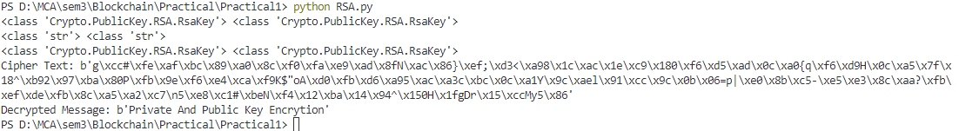

1. **Write a program to demonstrate the use of Hash Functions (SHA-256).**

**Code:-**

import hashlib

string ="hello how are you?"

encoded=string.encode()

result=hashlib.sha256(encoded)

print("String: ",end="")

print(string)

print("Hash value: ",end="")

print(result)

print("Hexadecima equivalent ",result.hexdigest())

print("Digest size: ",end="")

print(result.digest_size)

print("Block size: ",end="")

print(result.block_size)

**Output:-**

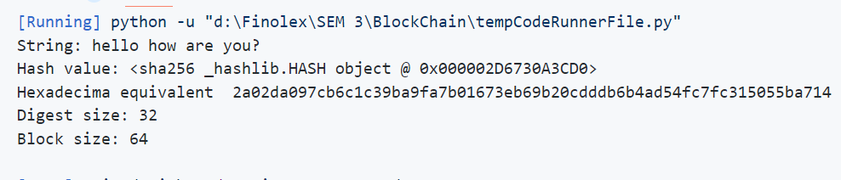

1. **Write a program to demonstrate Merkle Tree.**

**Code:-**

var merkle=require('merkle')

var str='Fred, Bret, Bill, Bob, Alice, Trent';

var arr=str.split(',');

console.log("Input:\t\t",arr);

var tree=merkle('sha1').sync(arr);

console.log("Root hash:\t",tree.root());

console.log("Tree depth:\t",tree.depth());

console.log("Tree levels:\t",tree.levels());

console.log("Tree nodes:\t",tree.nodes());

var i;

for (i=0;i<tree.levels();i++){

    console.log("\nLevels ",i);

    console.log(tree.levels(i));

}

**Output:-**

